**Homing Procedures**

If an incremental encoder is used in closed loop control with motor, it is not possible for the controller to know the absolute position of the motor when the system is initially powered up. To establish a known position, it is necessary to perform a search for a home or index mark. This is referred as initialisation or homing sequence.

The present document comprises the homing sequence design concept and control on TwinCAT 3 Software. To control the different homing sequences it is only needed to control 3 inputs.

**Note**: The program is thought to work with a NC Homing Sensor and NC Limit Switches.

There are two different velocities: velocity towards Home Sensor and velocity off Home Sensor. They will be access directly from the NC_axis (not through the PLC). They have the next addresses:

* **Homing Velocity towards Home Sensor:** 
  + **Index Group:** 0x0000400n
  + **Index Offset:** 0x00000006
  + **Length:** 8 (REAL type)

**n** = Axis id number

* **Homing Velocity off Home Sensor:** 
  + **Index Group:** 0x0000400n
  + **Index Offset:** 0x00000007
  + **Length:** 8 (REAL type)

**n** = Axis id number

**PLC Inputs:**

**• nCommand** (always =10)

• **nCmdData**

• **fHomePosition** (The position we want set after get the Reference Position)

• **nHomeRevOffset** (Number of Index …)

**Homing Procedure 1 : One of the limit switches (L+, L-) as reference position**

One of the mechanical limit switches can be chosen as a reference position from where the movement can start.

When the homing sequence starts, motor moves to the chosen limit switch in defined direction and activates the switch. After that it is considered that movement starts from zero position.

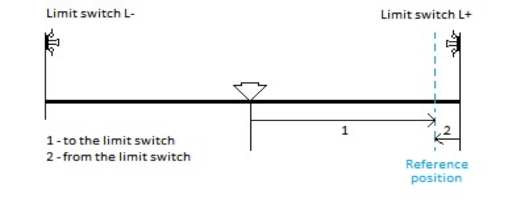

*Picture 1: Limit switch as reference position*

**nCommand =** 10

**nCmdData** = 1 (Backward direction (L-))

**nCmdData** = 2 (Forward direction (L+))

**fHomePosition** (The position we want set after get the Reference Position)

**Homing Procedure 2 : Home switch as reference position I**

Home switch can be chosen as reference position for the ending of the initialisation sequence and beginning point of the movement sequence.

When the homing sequence starts, motor moves to the chosen limit switch, activates it, and then moves away from it to the home switch. Referencing is done by activating home switch which has push button functionality but only from one direction.

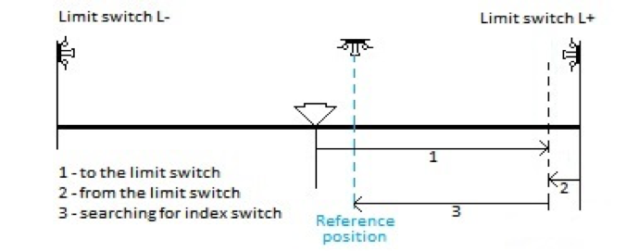

*Picture 2: Home switch as reference position I*

**nCommand =** 10

**nCmdData** = 3 (Backward direction (L-))

**nCmdData** = 4 (Forward direction (L+))

**fHomePosition** (The position we want set after get the Reference Position)

**Homing Procedure 3 : Home switch as reference position II**

Home switch can be chosen as reference position for the ending of the initialisation sequence and beginning of the movement sequence.

When the homing sequence starts, motor moves to the chosen limit switch, activates it, and then moves away from it to the home switch.

Referencing is done by approaching home switch from both directions and then calculating the middle or center position. Home switch has a push button functionality.

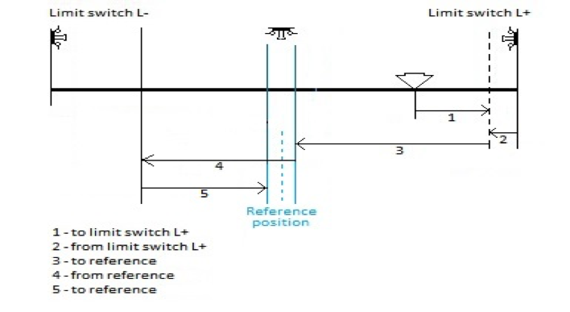

*Picture 3: Home switch as reference position II*

**nCommand =** 10

**nCmdData** = 5 (Backward direction (L-))

**nCmdData** = 6 (Forward direction (L+))

**fHomePosition** (The position we want set after get the Reference Position)

**Homing Procedure 4: Home switch as reference position III**

Home switch can be chosen as reference position for the ending of the initialisation sequence and beginning of the movement sequence. Referencing is done by activating a home switch which behaves like momentary switch (step function).

When this type of homing is used, no mechanical limit switches are needed.

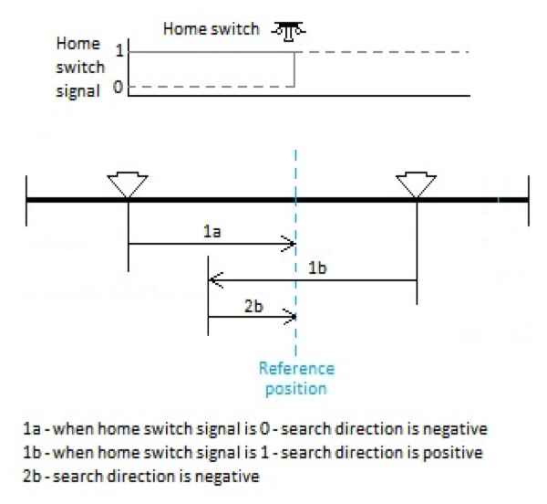

*Picture 4: Home switch as reference position III*

**nCommand =** 10

**nCmdData** = 7 or 8 (doesn’t matter, the direction is the same in both cases because depends on the sensor)

**fHomePosition** (The position we want set after get the Reference Position)

#### **Homing procedure 5:** **Index or reference point of an (incremental) encoder as reference position**

Index or reference point of an incremental encoder can be chosen as ending point of initialisation sequence and beginning of the movement sequence. Reference is nth index point from one end position defined by limit switch L+ or L-.

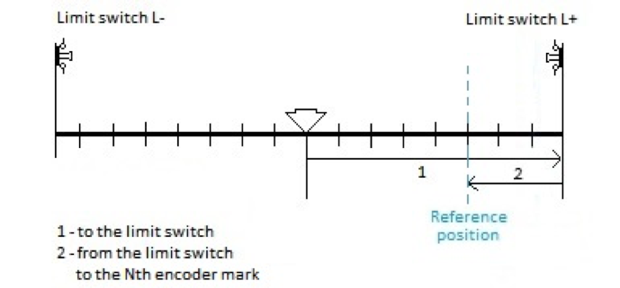

Picture 6. Index or reference position

**nCommand =** 10

**nCmdData** = 9 (Backward direction (L-))

**nCmdData** = 10 (Forward direction (L+))

**nHomeRevOffset** = Index number (drawing case =3)

**fHomePosition** (The position we want set after get the Reference Position)